Lab 01 – Làm quen với Git
Yêu cầu:
• Tạo một máy ảo Linux (Ubuntu hoặc Alma Linux).
# Cập nhật hệ thống
sudo apt update
sudo apt upgrade -y

# Cài đặt Git
sudo apt install git -y

# Kiểm tra phiên bản
git --version

# Cấu hình Git
git config --global user.name "NhuY"
git config --global user.email "2212500@dlu.edu.vn"

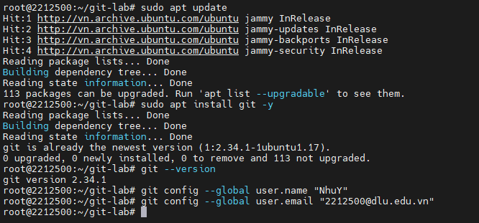
• Clone repository sau: https://github.com/eficode-academy/git-katas.git
# Tạo thư mục làm việc
mkdir ~/git-lab
cd ~/git-lab

# Clone repository
git clone https://github.com/eficode-academy/git-katas.git

# Di chuyển vào thư mục
cd git-katas
ls -la

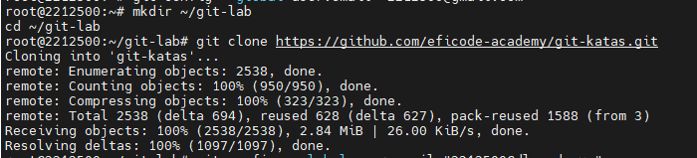
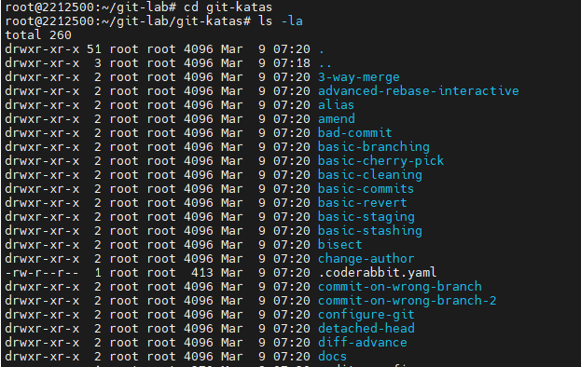
• Tham khảo trên Github và thực hiện cấc bài tập sau theo trình tự và hướng dẫn:
o Basic Commits
# Đọc hướng dẫn
cat README.md

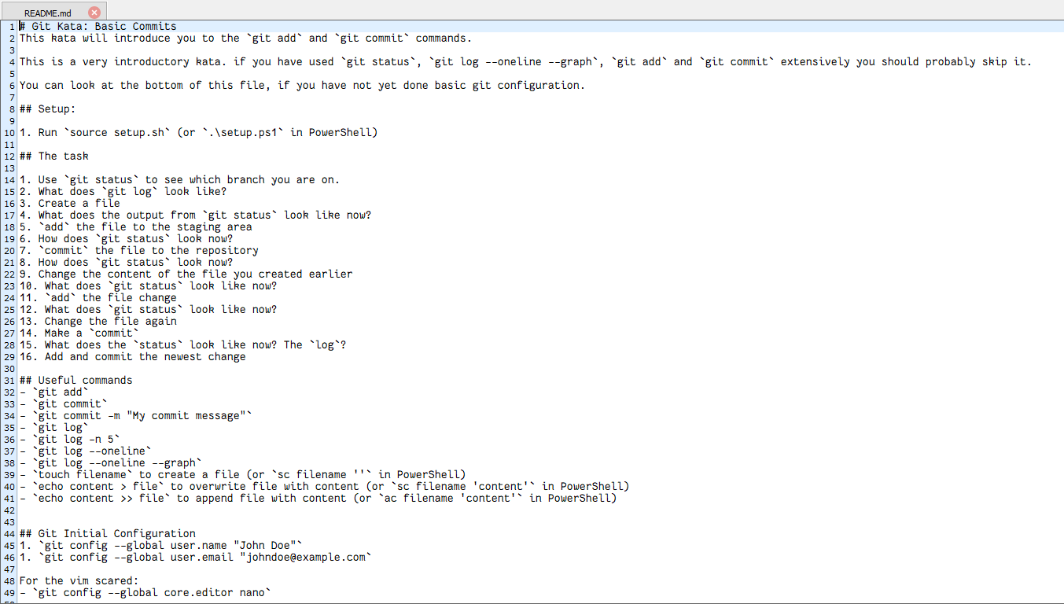
1. Use `git status` to see which branch you are on.
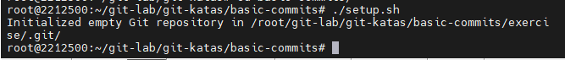
2. What does `git log` look like?
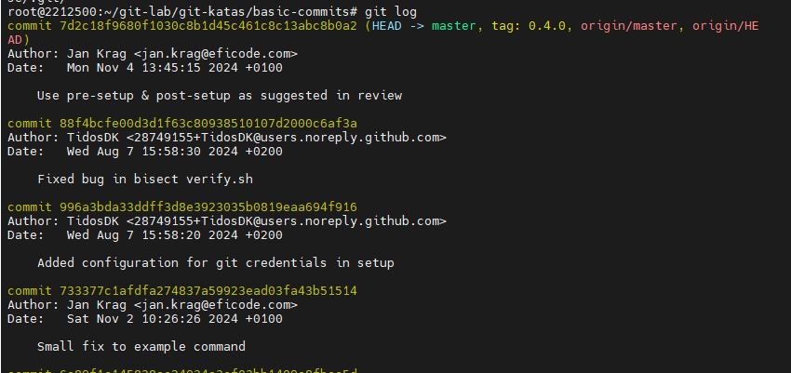
3. Create a file
4. What does the output from `git status` look like now?
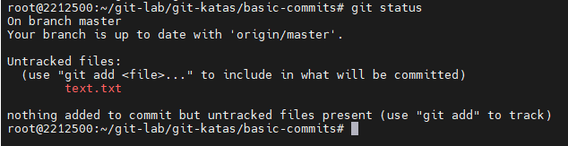
5. `add` the file to the staging area
6. How does `git status` look now?
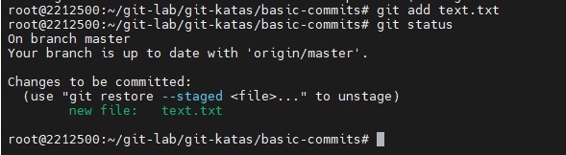
7. `commit` the file to the repository
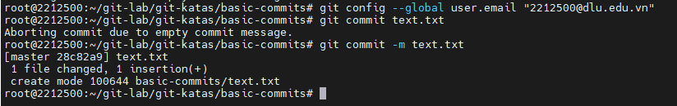
8. How does `git status` look now?
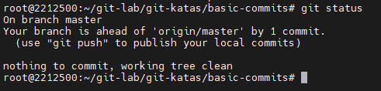
9. Change the content of the file you created earlier
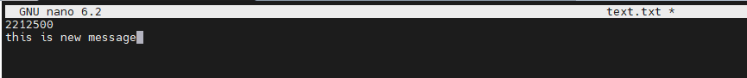
10. What does `git status` look like now?
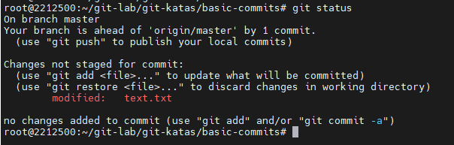
11. `add` the file change
12. What does `git status` look like now?
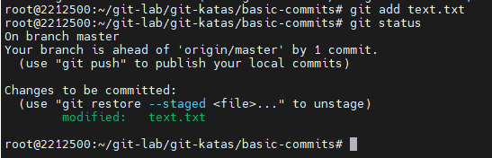
13. Change the file again
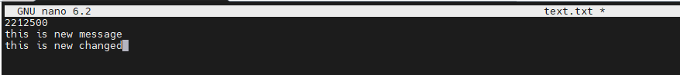
14. Make a `commit`
15. What does the `status` look like now? The `log`?
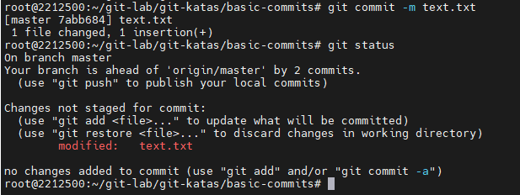
16. Add and commit the newest change
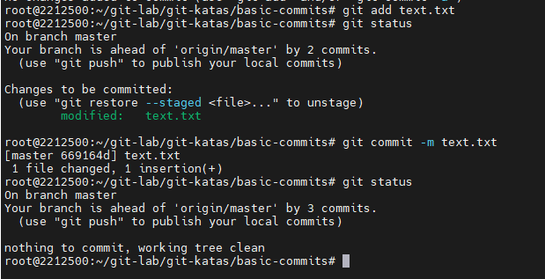
o Basic Staging
## Setup
1. Run `source setup.sh` (or `.\setup.ps1` in PowerShell)
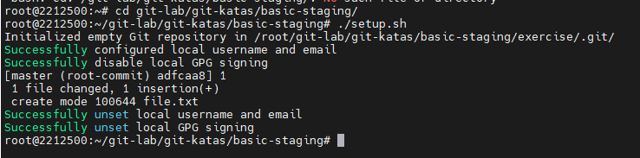
## The task
You live in your own repository. There is a file called `file.txt`.
1. What's the content of `file.txt`?
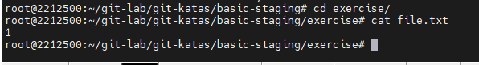
2. Overwrite the content in `file.txt`: `echo 2 > file.txt` to change the state of your file in the working directory (or `sc file.txt '2'` in PowerShell)
3. What does `git diff` tell you?
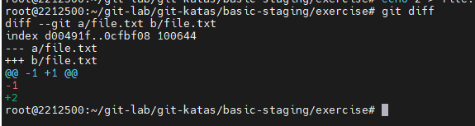
4. What does `git diff --staged` tell you? why is this blank?
- Because the file not yet ‘add’
5. Run `git add file.txt` to stage your changes from the working directory.
6. What does `git diff` tell you?
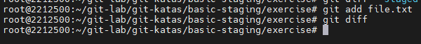
7. What does `git diff --staged` tell you?
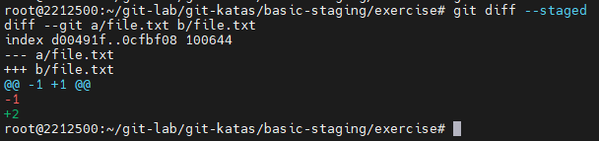
8. Overwrite the content in `file.txt`: `echo 3 > file.txt` to change the state of your file in the working directory (or `sc file.txt '3'` in PowerShell).
9. What does `git diff` tell you?
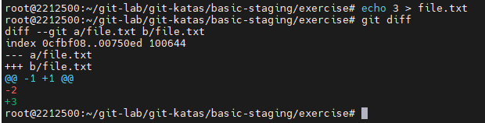
10. What does `git diff --staged` tell you?
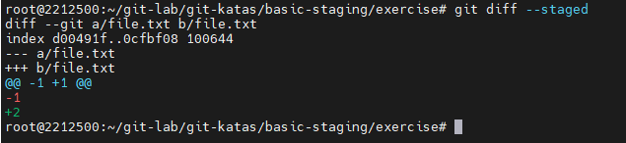
11. Explain what is happening
- The file was staged earlier, but it was modified again afterward. The new changes are
only in the working directory and have not been added to the staging area, so git diff --
staged shows no output
12. Run `git status` and observe that `file.txt` are present twice in the output.
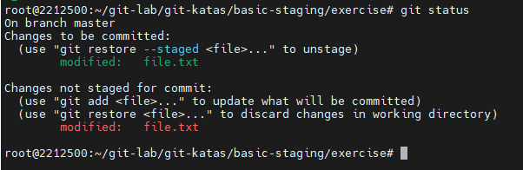
13. Run `git restore --staged file.txt` to unstage the change
14. What does `git status` tell you now?
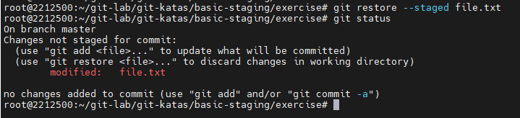
15. Stage the change and make a commit
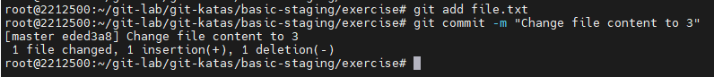
16. What does the log look like?
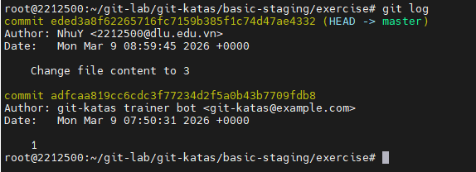
17. Overwrite the content in `file.txt`: `echo 4 > file.txt` (or `sc file.txt '4'` in PowerShell)
18. What is the content of `file.txt`?
19. What does `git status` tell us?
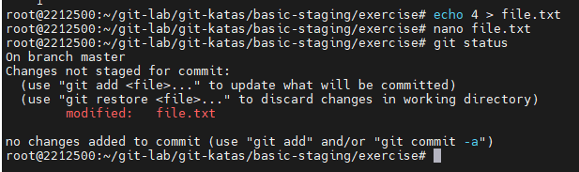
20. Run `git restore file.txt`
21. What is the content of `file.txt`?
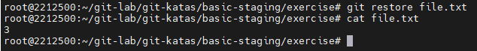
22. What does `git status` tell us?
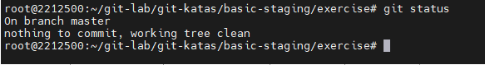
o Investigation
## Setup:
1. Run `source setup.sh` (or `.\setup.ps1` in PowerShell)
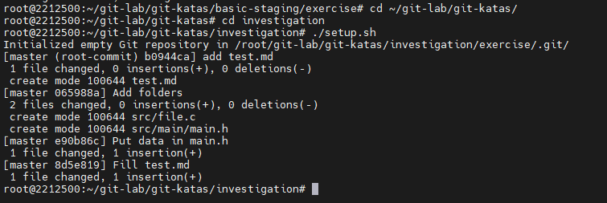
## Task
1. Using `git ls-tree` and `git cat-file`, draw the entire Git data structure.
- What tree and blob objects do you have and what do they point at?
Tree
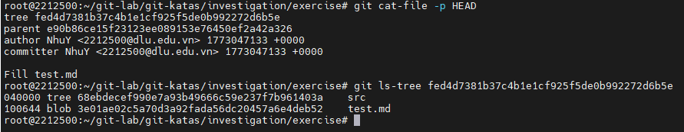
Blob objects
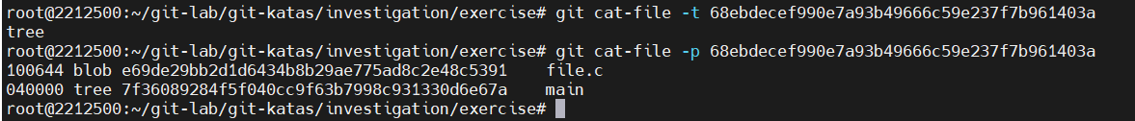
- What commits point inside this graph and where?
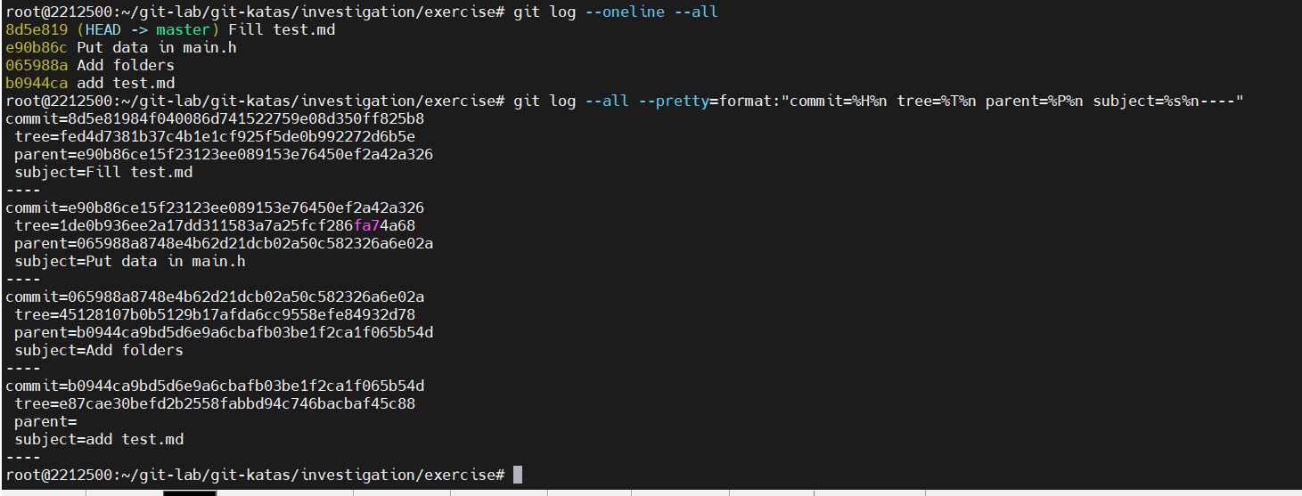
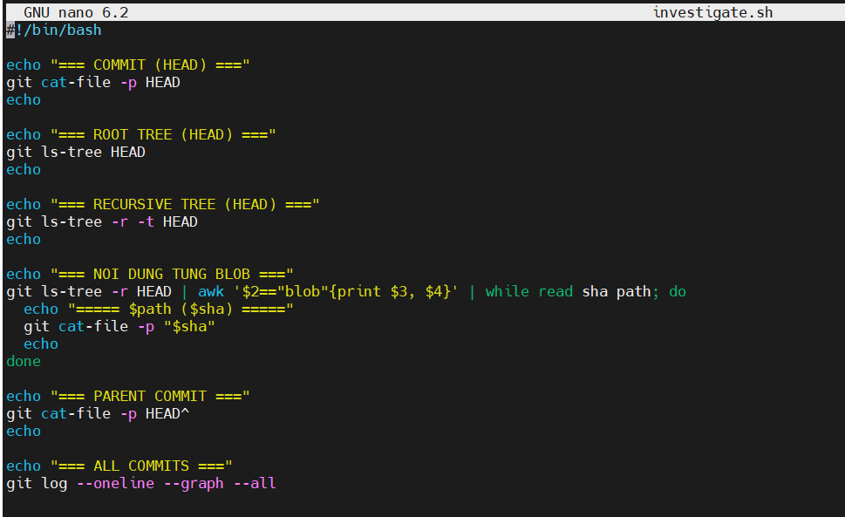
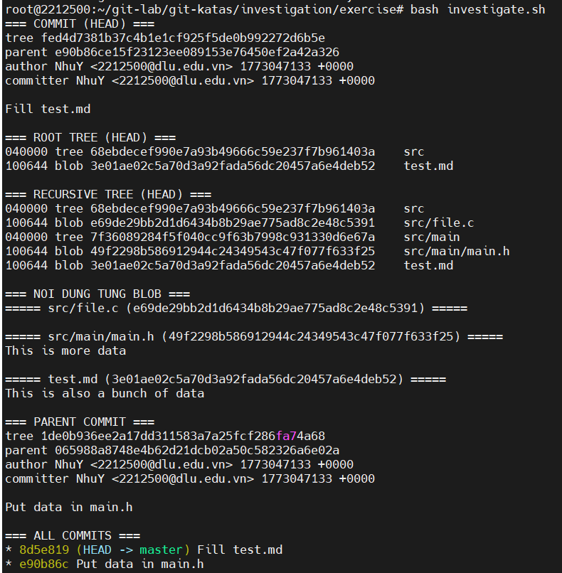
o Basic Branching
## Setup
1. Run `source setup.sh` (or `.\setup.ps1` in PowerShell)
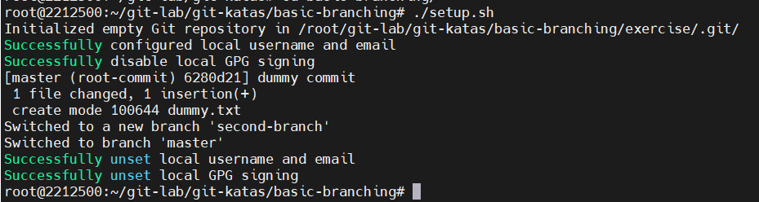
## The task
You again live in your own branch, this time we will be doing a bit of juggling with branches, to show how lightweight branches are in git.
Hint: `git switch` will make you switch from one branch to another.
1. Use `git branch` to see the two branches that are relevant for this exercise
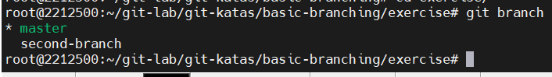
2. What branch are you on?
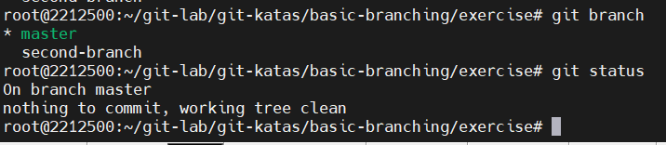
3. Use `git branch mybranch` to create a new branch called _mybranch_
4. Use `git branch` again to see the new branch created.
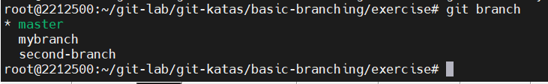
5. Use `git switch mybranch` to switch to your new branch.
6. How does the output from `git status` change when you switch between the _master_ and the new branch that you have created?
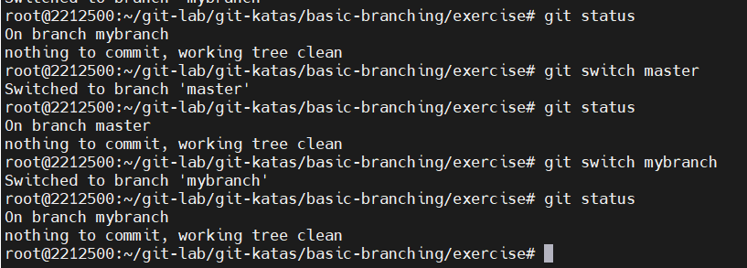
7. How does the workspace change when you change between the two branches?
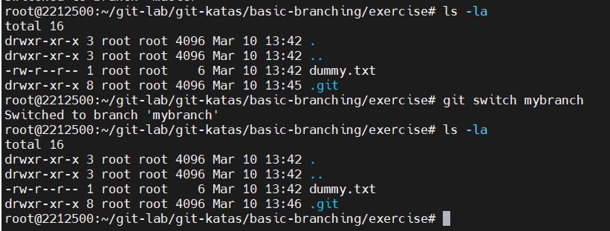
8. Make sure you are on your _mybranch_ branch before you continue.
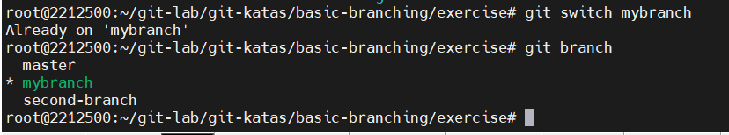
9. Create a file called `file1.txt` with your name.
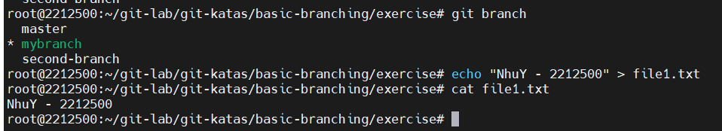
10. `Add` the file and `commit` with this change.
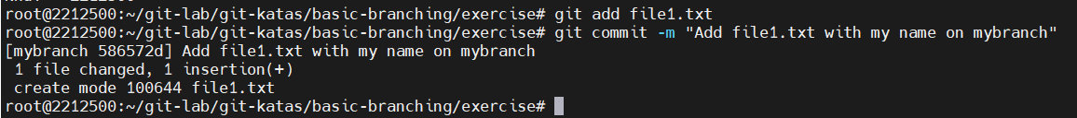
11. Use `git log --oneline --graph` to see your branch pointing to the new commit.
12. Switch back to the branch called _master_.
13. Use `git log --oneline --graph` and notice how the commit you made on the _mybranch_ branch is missing on the _master_ branch.
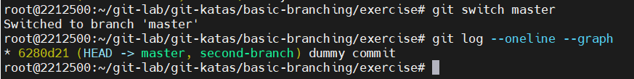
14. Make a new file called `file2.txt` and commit that file.
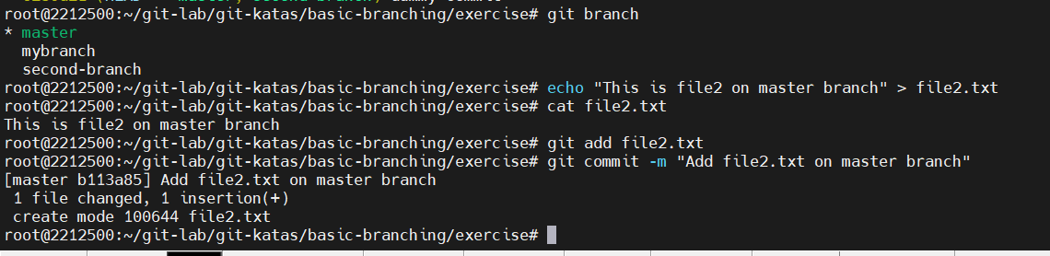
15. Use `git log --oneline --graph --all` to see your branch pointing to the new commit, and that the two branches now have different commits on them.
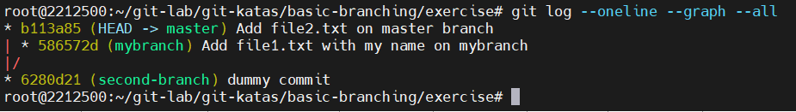
16. Switch to your branch _mybranch_.
17. What happened to your working directory? Can you see your `file2.txt`?
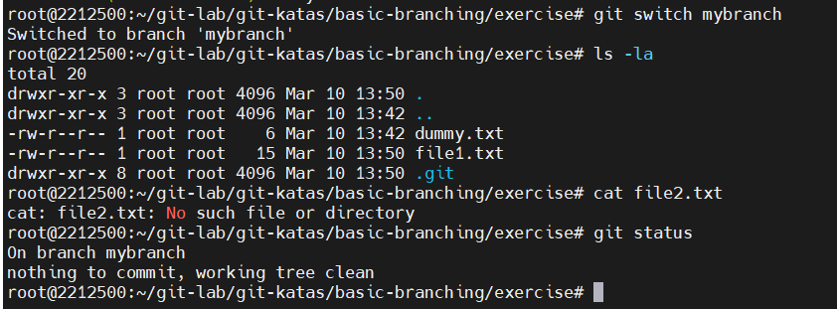
18. Use `git diff mybranch master` to see the difference between the two branches.
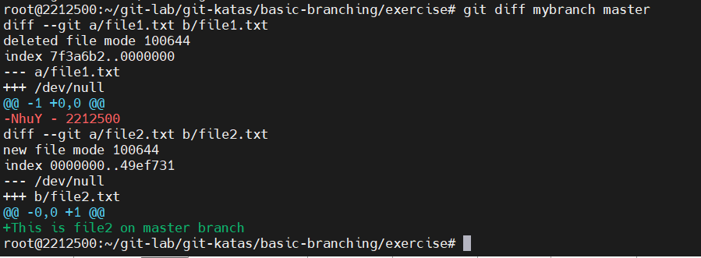
o Fast Forward Merge
## Setup
1. Run `source setup.sh` (or `.\setup.ps1` in PowerShell)
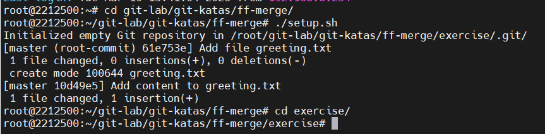
## The task
You again live in your own branch, this time we will be doing a bit of juggling with branches, to show how lightweight branches are in git.
1. Create a (feature)branch called `feature/uppercase` (yes, `feature/uppercase` is a perfectly legal branch name, and a common convention).
2. Switch to this branch
3. What is the output of `git status`?
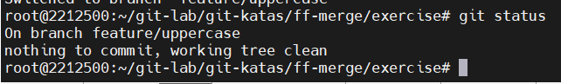
4. Edit the greeting.txt to contain an uppercase greeting
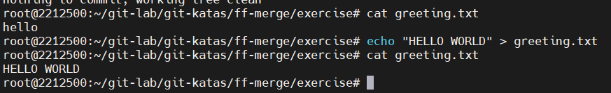
5. Add `greeting.txt` files to staging area and commit
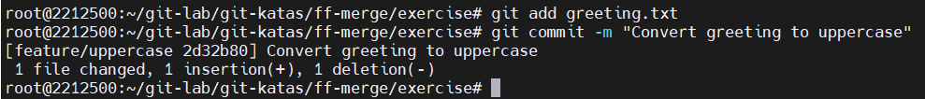
6. What is the output of `git branch`?
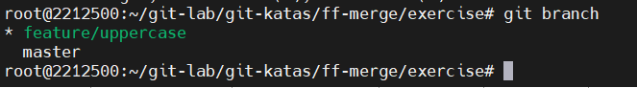
7. What is the output of `git log --oneline --graph --all`
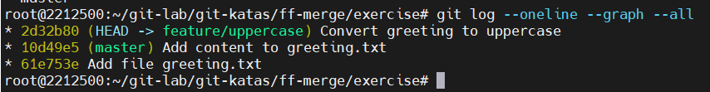
*Remember: You want to update the master branch so it also has all the changes currently on the feature branch. The command 'git merge [branch name]' takes one branch as argument from which it takes changes. The branch pointed to by HEAD (currently checked out branch) is then updated to also include these changes.*
8. Switch to the `master` branch
9. Use `cat` to see the contents of the greetings
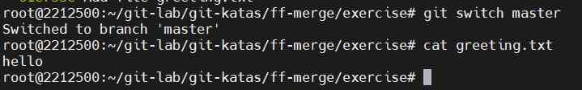
10. Diff the branches
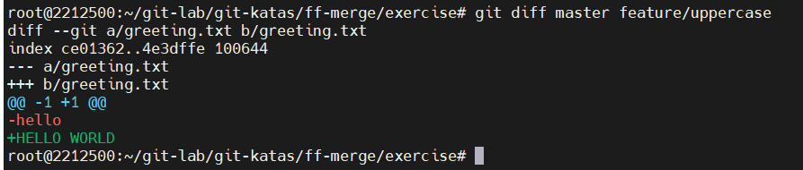
11. Merge the branches
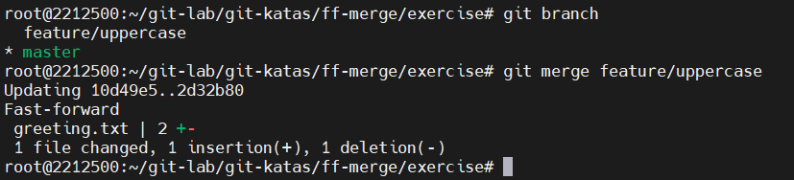
12. Use `cat` to see the contents of the greetings
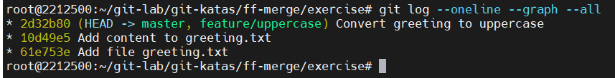
13. Delete the uppercase branch
o 3 way Merge
## Setup
1. Run `source setup.sh` (or `.\setup.ps1` in PowerShell)
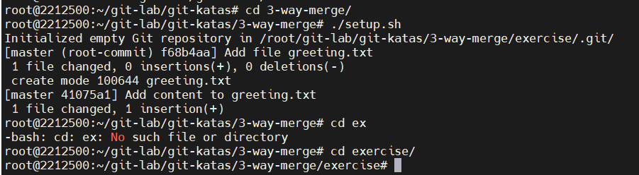
## The task
You again live in your own branch, this time we will be doing a bit of juggling with branches, to show how lightweight branches are in git.
1. Create a branch called greeting and switch to it
2. Edit the greeting.txt to contain your favorite greeting
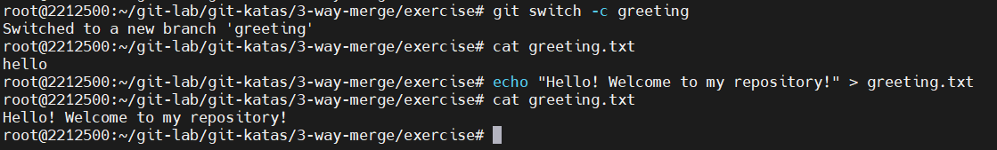
3. Add greeting.txt files to the staging area
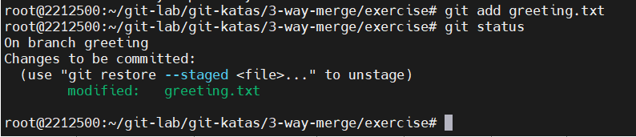
4. Commit
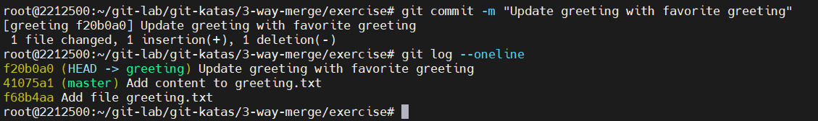
5. Switch back to the master branch
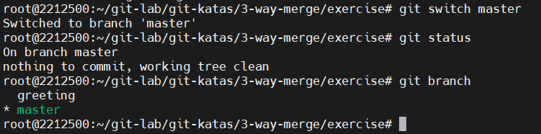
6. Create a file README.md with information about this repository
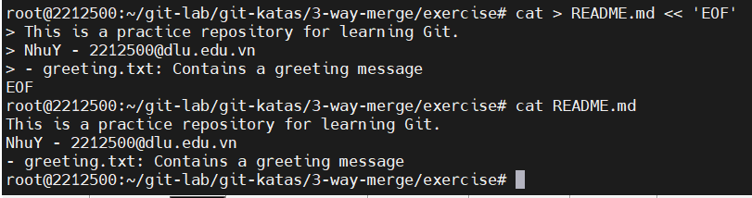
7. Add the README.md file to staging area and make the commit
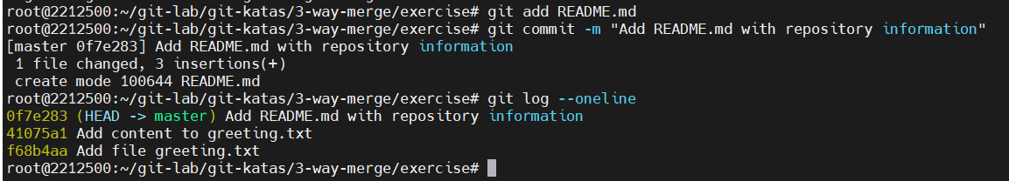
8. What is the output of `git log --oneline --graph --all`?
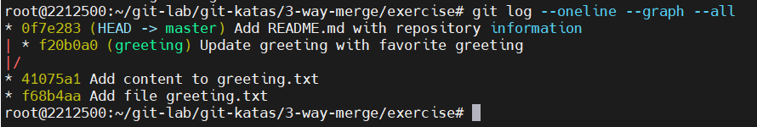
9. Diff the branches
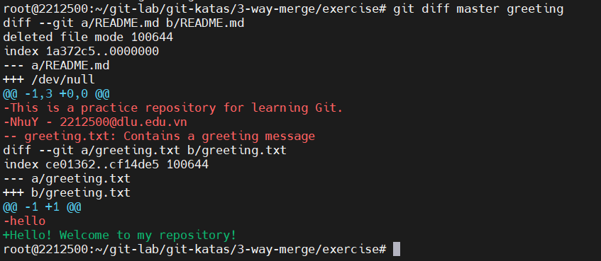
10. Merge the greeting branch into master
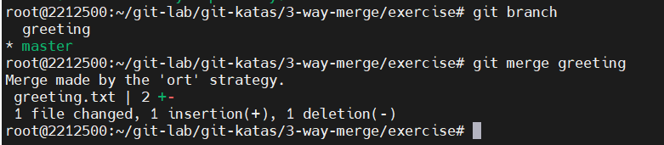
11. What is the output of `git log --oneline --graph --all` now? Observe the extra merge commit created with the message "Merge branch 'greeting'".
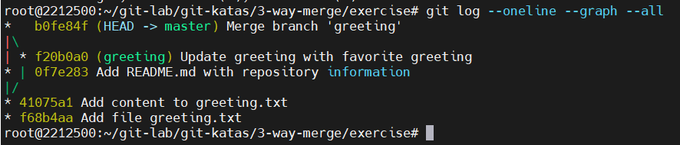
o Merge Mergesort
## Setup:
1. Run `source setup.sh` (or `.\setup.ps1` in PowerShell)
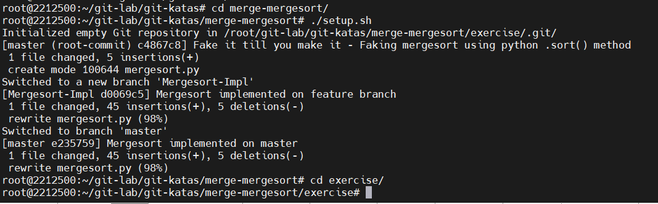
## The task
1. Run `git branch` to see the two branches present
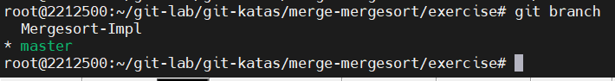
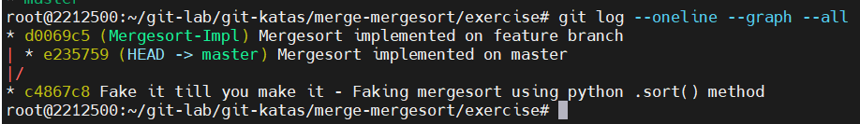
2. Merge `Mergesort-Impl` into `master`
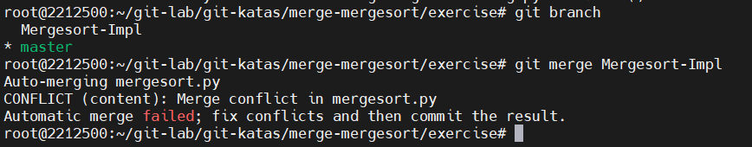
3. Either:
1. Solve the merge conflict with your favorite editor and finish the merge (`git status` will tell you what to do), **or**
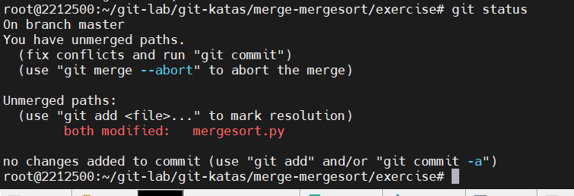
2. Use `git mergetool --tool=emerge` (for emacs fans) or `git mergetool --tool=vimdiff` (for vim fans) and finish the merge (`git status` will tell you what to do)
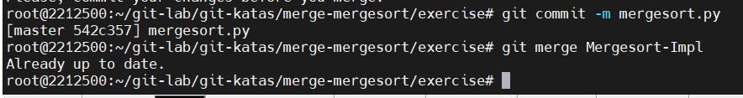
o Rebase Branch
## Setup
1. Run `source setup.sh` (or `.\setup.ps1` in PowerShell)
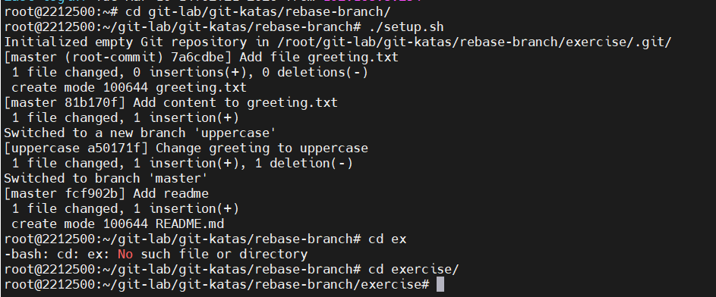
## The task
You again live in your own branch, this time we will be doing a bit of juggling with branches, to show how lightweight branches are in git.
1. Which branches exist?
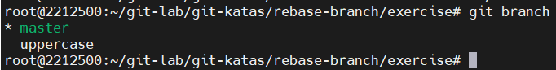
2. Look at the log for the master branch
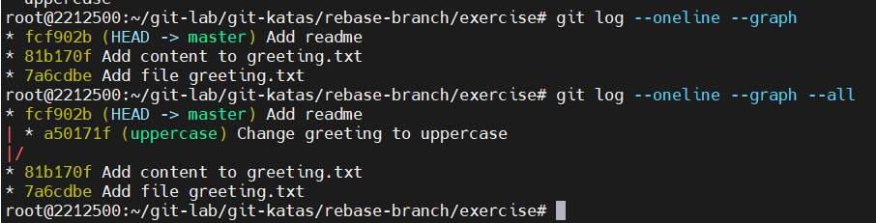
3. Switch to the uppercase branch
4. How does the log compare to the log on the master branch?
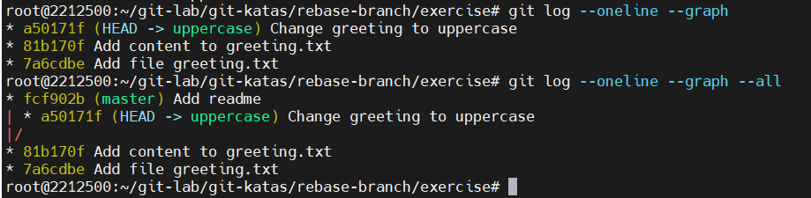
5. Rebase your uppercase branch with the master (`git rebase master`)
6. What did just happen? Draw it!
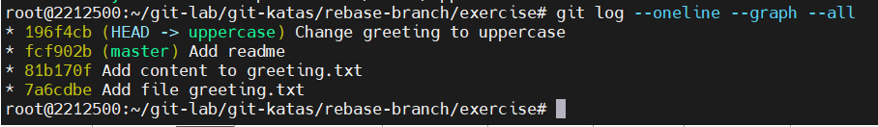
7. Now switch to the master branch
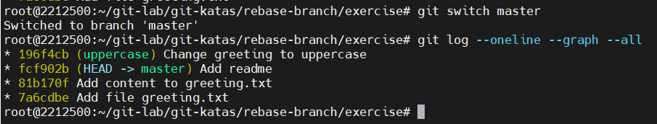
8. Merge uppercase into master
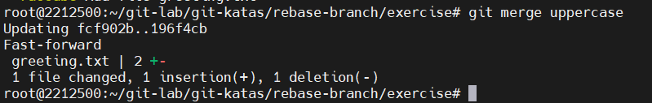
9. What does the log look like now?
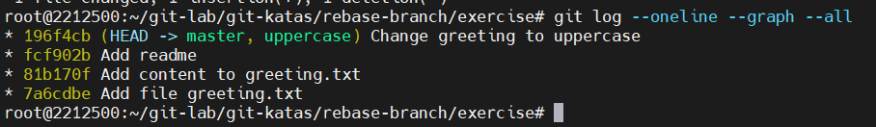
o Basic Revert
## Setup:
1. Run `source setup.sh` (or `.\setup.ps1` in PowerShell)
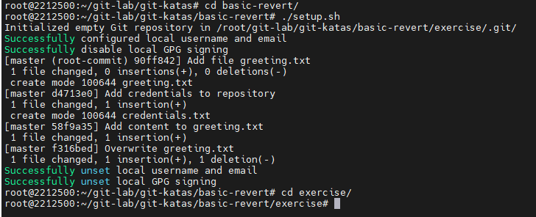
## The task
In this task a few changes snuck in, that we'd like to get out. Our history is public, so we can't just change it. Rather we need to use revert to remove the unwanted changes in a safe way.
1. Use `git log --oneline` to look at the history
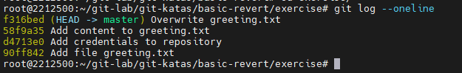
2. Use `cat` to view the content of `greeting.txt`
3. Use `git revert` on the newest commit, to remove the changes the last commit added
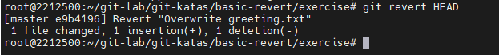
4. Use `git log --oneline` to view the history
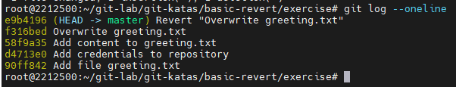
5. Did the revert command add or remove a commit?
git revert thêm 1 commit vào lịch sử
6. Use `cat` to view the content of `greeting.txt`
7. Use `ls` to see the content of the workspace
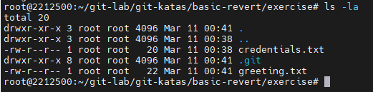
8. Use `git log --oneline` to find the sha of the commit adding credentials to the repository
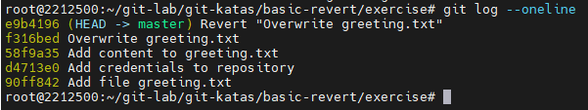
9. Use `git revert` to revert the commit that added the credentials
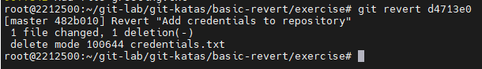
10. Use `git log --oneline` to view the history
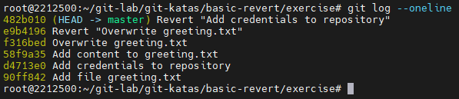
11. Use `ls` to see the content of the workspace
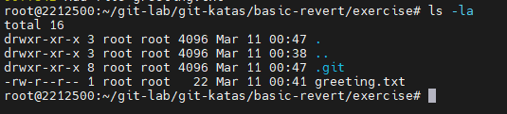
12. How many commits were added or changed by the last revert?
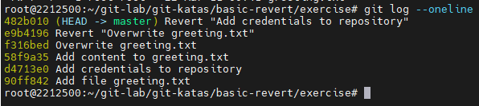
git revert thêm 1 commit mới vào lịch sử
13. Use `git show` with the sha of the commit you reverted to see that the credentials file is stilll in the history
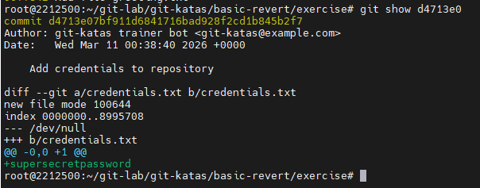
14. As you have now reverted the credentials file, so it is removed from your working directory, is it also removed from git?
File credentials không bị xóa khỏi Git history
o Reset
## Setup
1. Run `source setup.sh` (or `.\setup.ps1` in PowerShell)
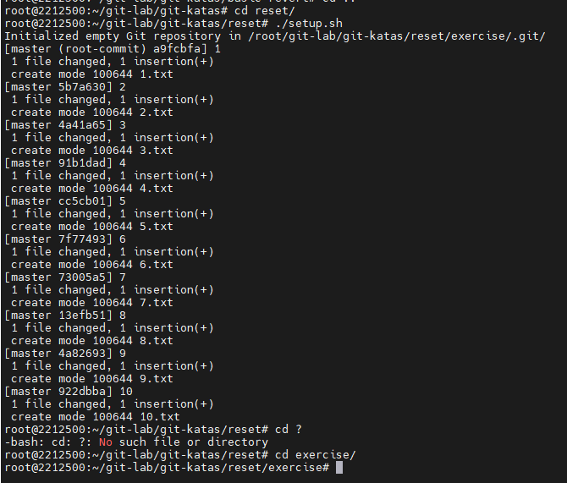
## Task
1. How does your working directory look like?
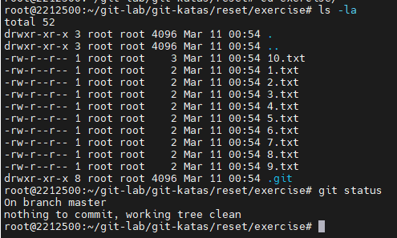
2. What does your log look like? What does your stage look like?
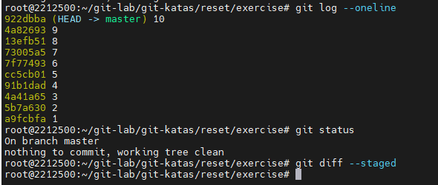
3. Try to run `git reset --soft HEAD~1`
4. What happens to your working directory, your log and your stage?
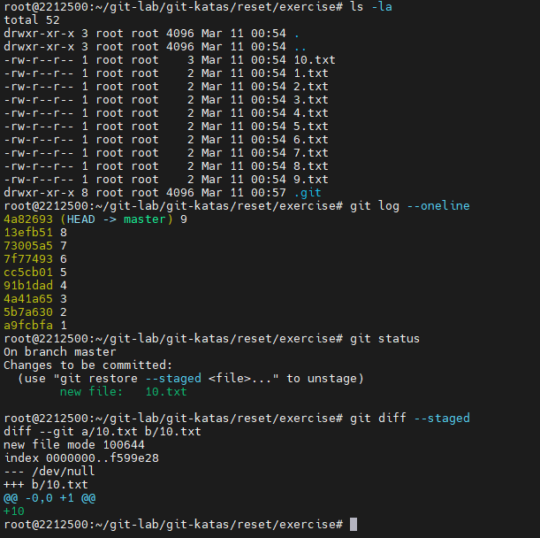
5. Run `git reset --mixed HEAD~1`
6. What happens to your working directory, your log and your stage?
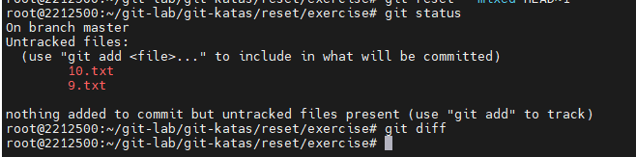
7. Run `git reset --hard HEAD~1`
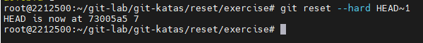
8. What happens to your working directory, your log and your stage?
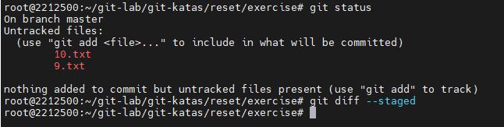
9. Now try to use `git revert HEAD~1`
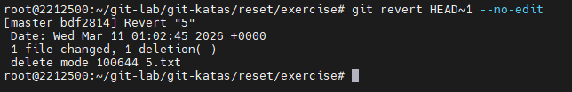
10. What happens to your working directory, your log and your stage?
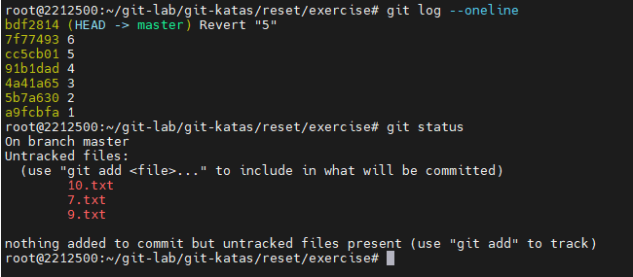
o Basic Cleaning
## Setup:
1. Run `source setup.sh` (or `.\setup.ps1` in PowerShell)
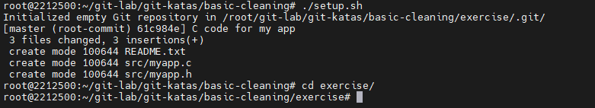
## The task
You are working on a project that involves generated files. Say you are compiling C files into object files. Before checking out a new branch you want to start clean
1. Explore the directory with `ls -R`. There is a lot going on. Code files, temp files, object files,.. Let's clean up!
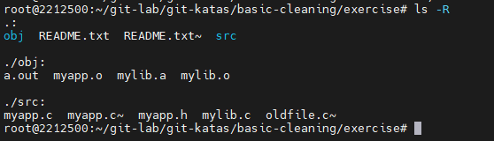
2. Just to be safe, do a dry run and execute the clean command with the ` -n` option
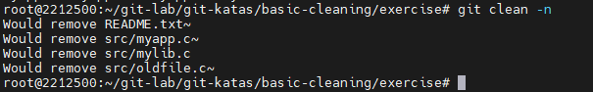
3. Oh noes! there's a `.c` file that would have been deleted!
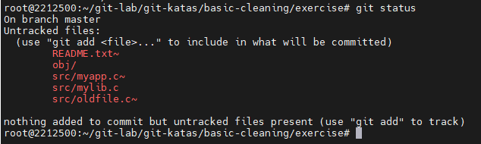
4. Add `src/mylib.c` to the staging area. don't commit it.
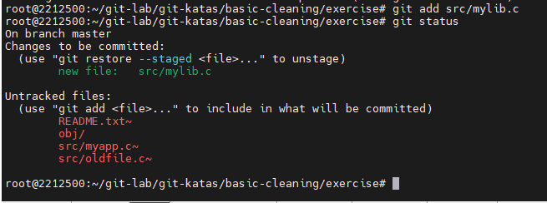
5. Run the clean command with the ` -n` option. Notice that mylib.c will not be deleted. Also notice that the files in the obj directory are not listed
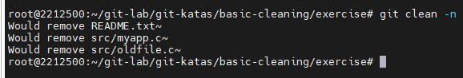
6. Run the clean command with the ` -n -d ` option.
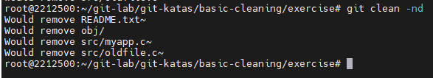
7. Looks good! clean the repo ` -f -d `
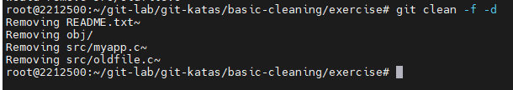
o Amend
## Setup:
1. Run `source setup.sh` (or `.\setup.ps1` in PowerShell)
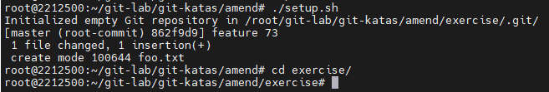
## The task
1. What does `git status` tell us?
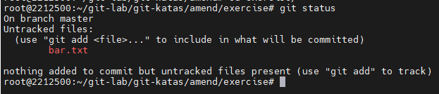
2. What does `git log -p` tell us?
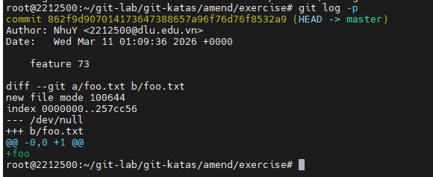
3. Stage the addition of bar.txt
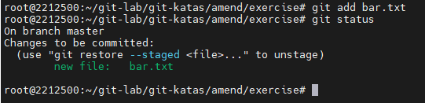
4. Run `git commit --amend`
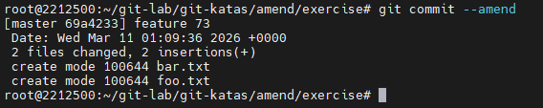
5. What happened? What does `git log -p` tell us?
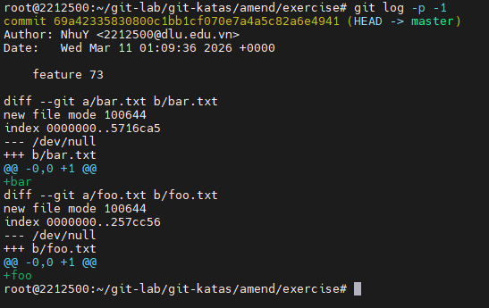
6. What happens if you run `git commit --amend` again?
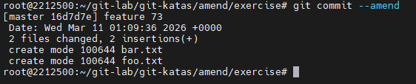
o Reorder the History
## Setup
1. Run `source setup.sh` (or `.\setup.ps1` in PowerShell)
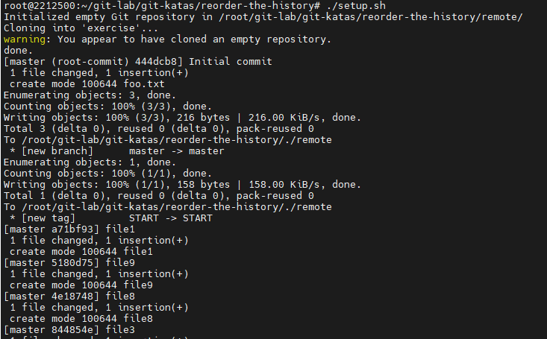
## Task
Reorder the history such that it actually makes sense - add the files in the order that matches their name.
1. Use `git log --oneline --graph` to view the commits
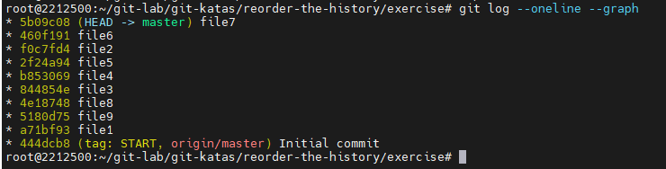
2. Also try `git reflog` to view the commits. `git reflog` defaults to `git reflog show` and this is an alias for `git log -g --abbrev-commit --pretty=oneline`
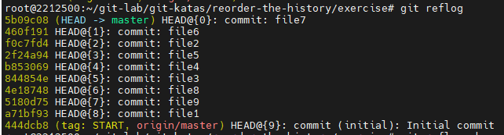
3. Use `git rebase -i <after-this-commit>` to reorder the commits. There are commments in the file you edit that explain the commands available.
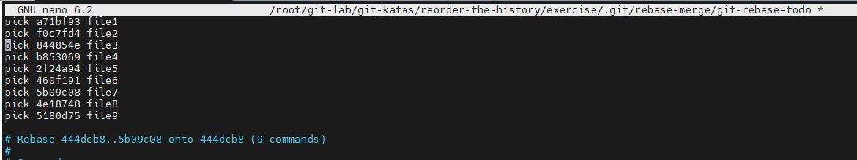
4. Use `git log --oneline --graph` to view the result
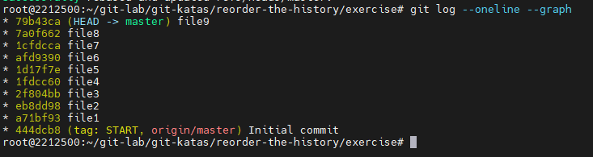
o Advanced Rebase Interactive
## Setup:
1. Run `source setup.sh` (or `.\setup.ps1` in PowerShell)
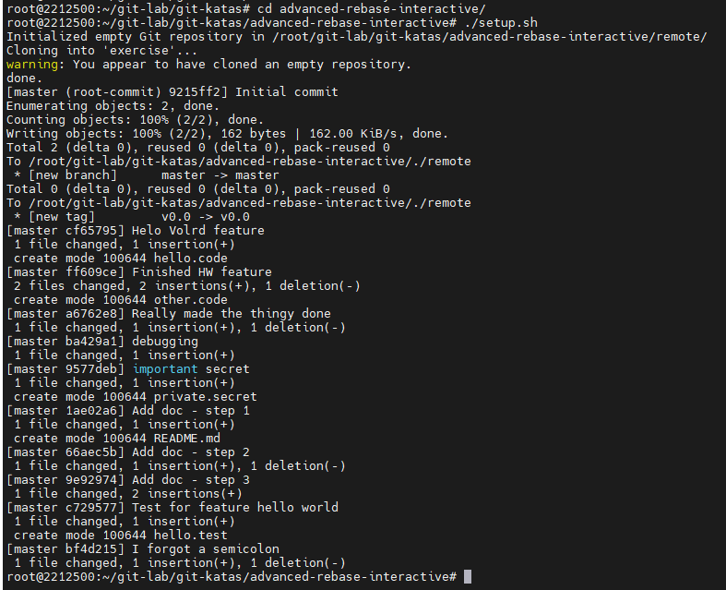
## Task
1. Explore the repo and the history so you know what happened
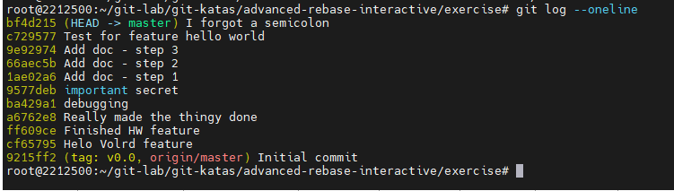
2. Use `git rebase --interactive v0.0` to let you edit the "recipe" for the entire feature development.
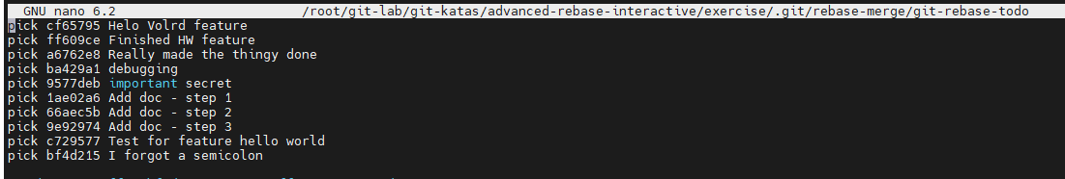
3. Clean up the history such that it actually makes sense. Try to use as many of the rebase "features" (e.g. reword, squash, fixup, drop) as possible. You decide yourself if you want to rewrite the whole thing in one go, or apply a few changes first, then run a new `git rebase --interactive v0.0` to keep cleaning.
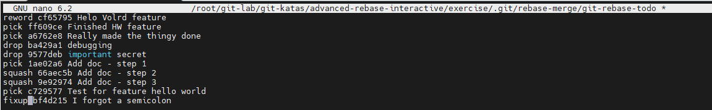
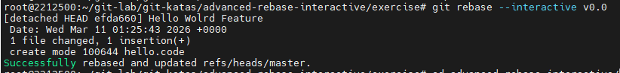
o Rebase using autosquash
## Setup:
1. Run `. setup.sh` (or `.\setup.ps1` in PowerShell)
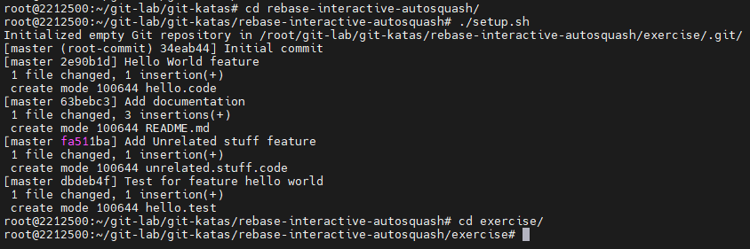
## Task
1. Explore the repo and the history so you know when the documentation file was added.
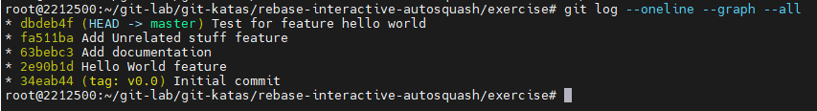
2. Fix `README.md` file and add it.
Fix
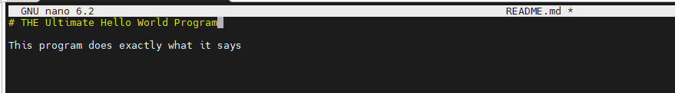
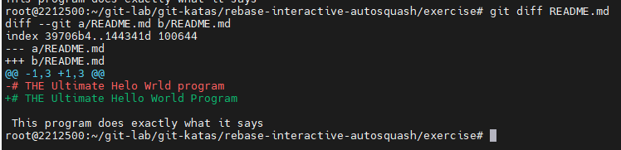
Add
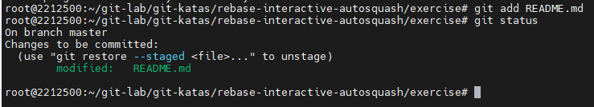
3. Add your commit by using `git commit --fixup=<commit id to be fixed>`.
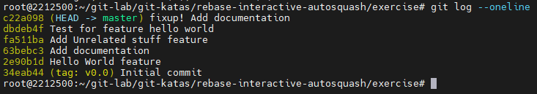
4. Use `git rebase --autosquash --interactive v0.0` to view the rebase recipe automatically generated.
5. Use `git log` to view your new beautiful history.
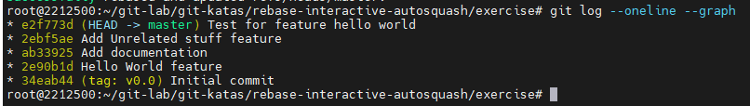
o Basic Stashing
## Setup:
1. Run `source setup.sh` (or `.\setup.ps1` in PowerShell
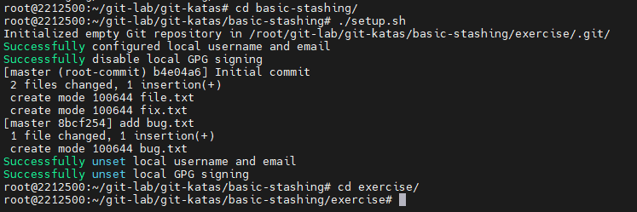
## The task
You are working on your project. You've staged some work and have some unstaged work as well.
Suddenly, you're made aware that a bug has made it to production. You'll stash your work, fix the bug and get back to your original work.
1. Explore the repo
1. What work do you have in the working directory?
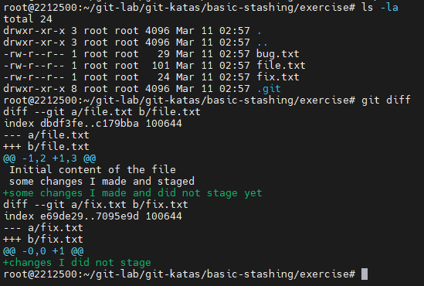
2. What work do you have staged ?
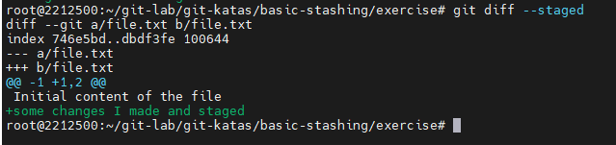
3. What does the commit log look like ?
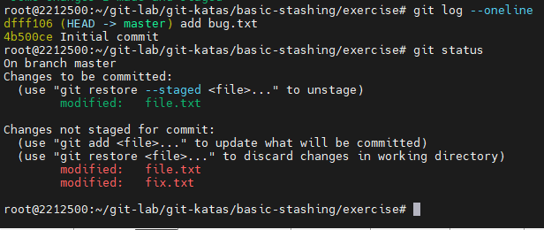
>*Notice that file.txt has some staged changes (i.e. changes in the index) and unstaged changes (changes in the working directory)*
2. Use `git stash` to stash your current work.
1. Now, what work do you have in the working directory?
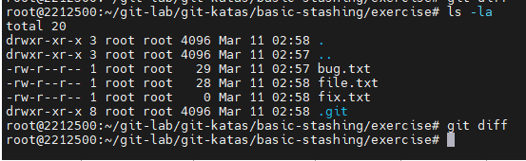
2. What work do you have staged ?
3. What does the commit log look like ?
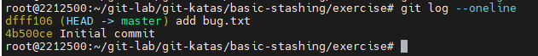
4. What does the stash list look like ?
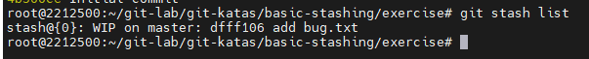
3. Fix the typos in bug.txt on master and commit your changes.
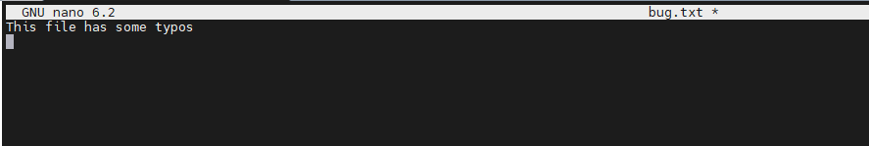
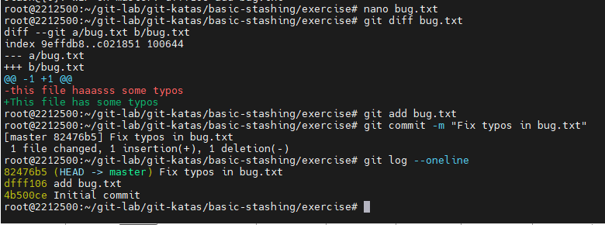
4. Now to get back to your work, apply the stash to master.
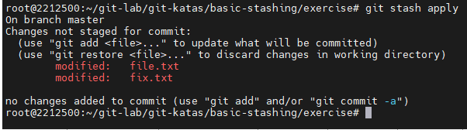
1. What work do you have in the working directory?
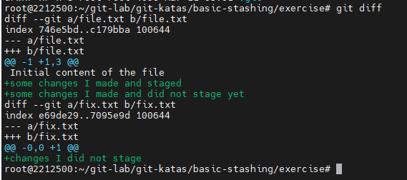
2. What work do you have staged ?
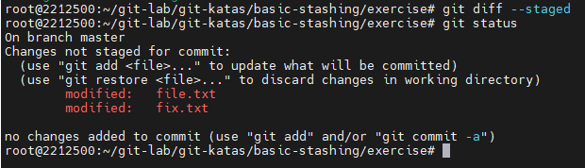
>*Oops. All our changes are unstaged now. This may be undesirable and unexpected*
5. Undo our changes with `git reset --hard HEAD`. This is an unsafe command as it will remove files from your index and working directory permanently, but we have our changes safely stashed so we're ok. Review the [reset](reset/README.md) kata if you're unsure of what happens here.
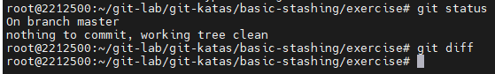
6. Apply the stash to master with the `--index` option.
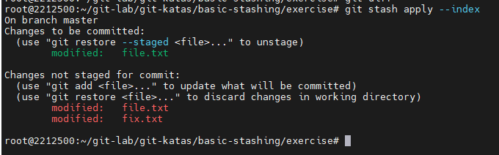
1. What work do you have in the working directory?
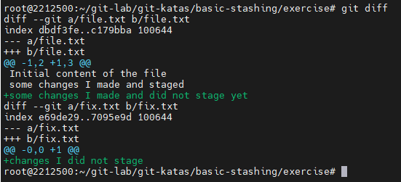
2. What work do you have staged ?
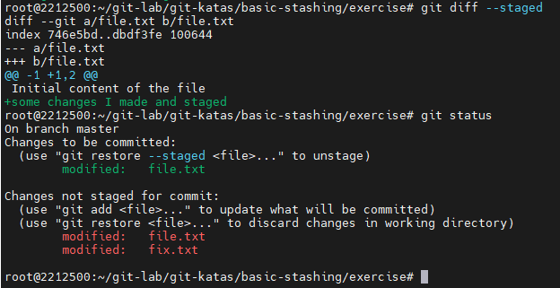
>*Ok, back to where we were!*
7. We won't need the stash anymore. Drop it.
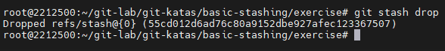
1. What does the stash list look like ?
2. What does the commit log look like ?
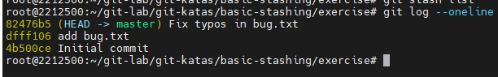
Chụp lại các bước đã thực hiện vào 1 file word (Ghi kỹ từng bài tập).
Tạo một tài khoản github, tạo một repo và và commit kết quả kèm file word lên repo đó.
Bài lab sẽ được kiểm tra trên repo của sinh viên.
